**[Mobile Car Services Project Synopsis](https://1000projects.org/mobile-car-services-project-synopsis.html)**

**Abstract:**

* Mobile Car Services is one of the features in the automobile industry that lets you find the right dealers from the application.
* End Users & Dealers needs to register in the application and customers can schedule the car service at his own priority times.
* The aim of the study is to propose a Web-Based Application to bring the dealers and customers on one platform with minimal cost.

**Motivation:**

* It brings cleaning service at your doorsteps and also saves your energy.

**Introduction:**

* The simple concept behind the Mobile Car Wash service is using idle parking time while owners leave their cars to carry out other activities, such as shopping, working, entertaining, studying, etc.

**Software Requirements:**

* Windows 7 ,8,10,ubuntu
* WAMP Server 2.1e / LAMP Server / XAMPP Server
* Notepad++
* Filezilla client

**Applications:**

* Public and private companies parking
* Residential parking

**Cost Management**

**FROM DEVELOPERS END**

* Hosting: Rs.3000
* Domain: Rs.1500 per annum.

**FROM CUSTOMERS END**

* The bill is generated only for the services acquired.

**Work Breakdown Structure**

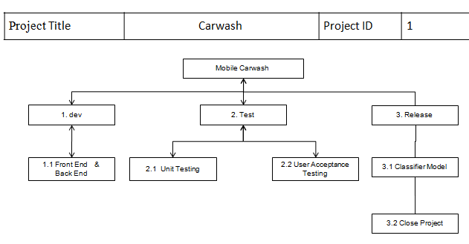

**Modules:**

The following modules are identified in the project:

* Admin Module
* Dealers Module
* Booking Module

**Admin Module:**

* The admin module is the most important module in the project.
* It manages the information regarding the approval and disapproval of the dealers.
* This module maintains the record regarding the bookings made by the customer, the total number of dealers and also it maintains a record for the pending requests of dealers.

**Dealer Module:**

* This module is all about the dealers that are associated in the portal.

**Dealers Module Data Flow Diagram:**

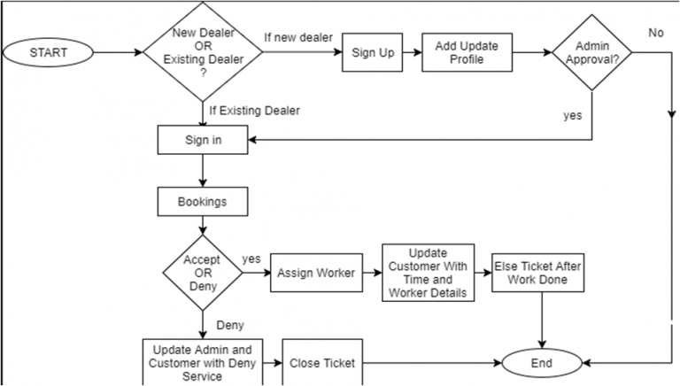

**Booking Module:**

* This is the module where all the information related to the customers such as the bookings, payments, etc. are maintained.
* In this portal, even the customers have a login form which is mandatory when booking a service.

**Booking Module DFD:**

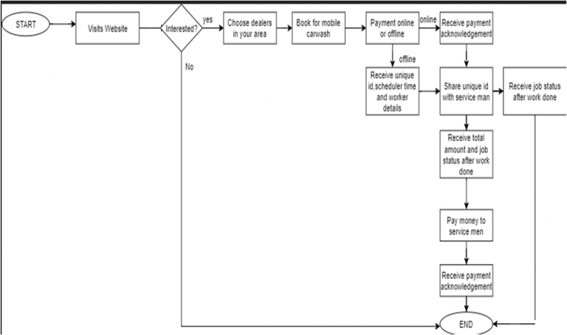

**Sequence Diagram:**

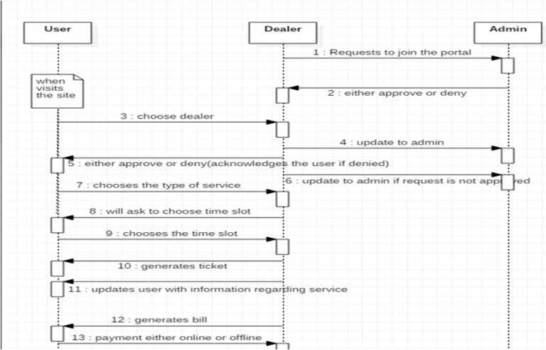

**Method of solution  related to Problem**

* The solution we found is to develop a specific platform like a web portal which helps to enhance the bridge between service person and customer.
* Previously, each company dealer has its own business platform, instead, we made a platform wherein it brings all the dealers to a single platform.

**Usability:**

* This portal is user-friendly.
* Provides with the best services anywhere as per the customer requirement.
* One platform where a customer will have to choose the dealer from a given list.

**Database Connectivity:**

It’s a cinch to connect to a database with MySQL.

* Admin
* Dealer
* Booking

**ER Diagram:**

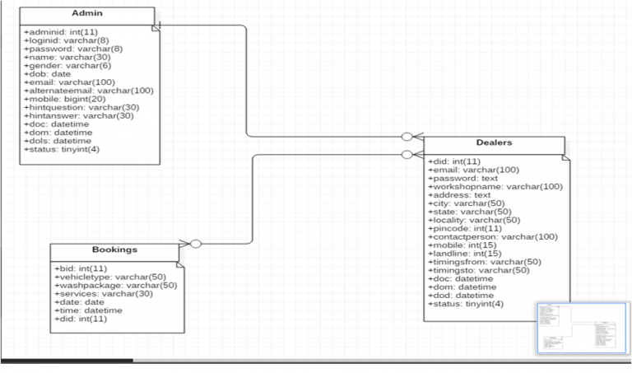

**Conclusion:**

* Working on this project Mobile Car Services, we come to the conclusion that such automation systems are quite beneficial and saving the time of operation.
* It also reduces manpower.
* Thereby increasing the economy of the system in the future, such kind of systems are increasing in demand.